BK Exports

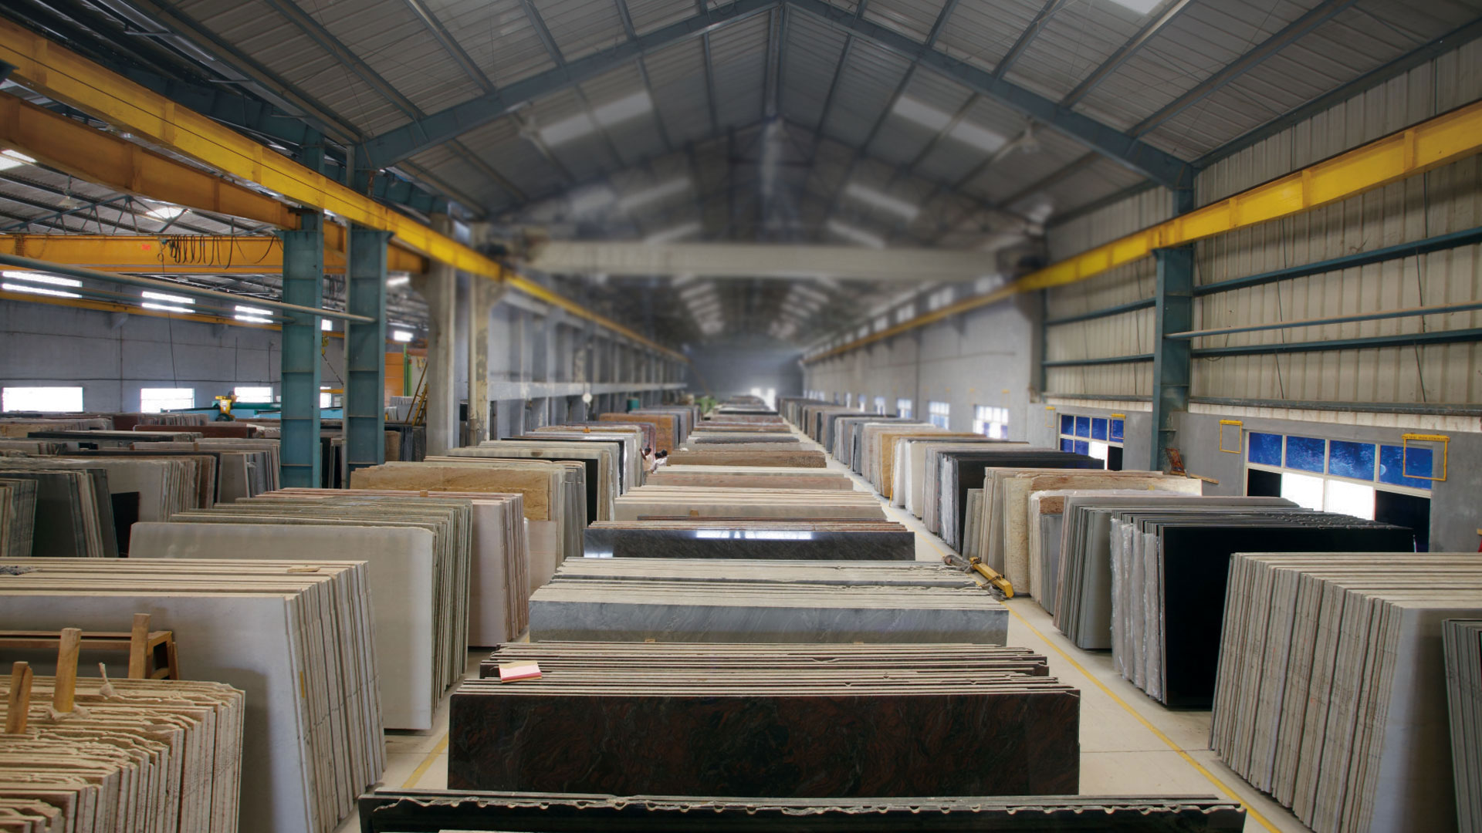

**BK Exports is the leading and most reputed Exporter, manufactures and wholesale supplier of natural stones like marble, granite, ceramic tiles, Artificial, Quartz, Porcelain Slab in the international market. premium quality flawless finish.**

**It was established by our respected owner Mr. Alpesh Jain with a vision of becoming leader of the market. Mr. Alpesh Jain has years of industry experience and excels at management process. His excellence and team hardwork has taken the company to new horizons.**

About Us

**Overview:**

We always aim to be a globally respected company and to remain one of the leading stone companies in the country. We aspire to be the market leader in the marble, Granite Natural stone and Ceramic industry through our extreme commitment, quality, integrity and customer value, we believe that our customers are the true identity of our company

**We deal in:** Porcelain Slab, Quartz, Sandstone, Limestone, Granite and Marble

**Contact Details:**

**Company Name: Bk Exports**

**Address:** 90, Jashodanagar Cross Road, Nr. Canal, Opp. Baroda Express Highway, Ahmedabad, Gujarat, India - 380026.

**Contact No.:** +91 98256 65125,

+91 93130 35076

**Email Address:** [**info@bkexportsinternational.com**](mailto:info@bkexportsinternational.com)

|  |  |
| --- | --- |
|  | **Description:**  **Name:** Alaska white  **Thickness:** 18 mm UP  **Size:** Gangsaw and Cutter Slab |
|  |  |
|  | **Description:**  **Name:** Alaska Gold  **Thickness:** 18 mm UP  **Size:** Gangsaw and Cutter Slab |
|  |  |
|  | **Description:**  **Name:** Blue Dunes  **Thickness:** 18 mm UP  **Size:** Gangsaw and Cutter Slab |
|  |  |
|  | **Description:**  **Name:** Petagonia  **Thickness:** 20 mm UP  **Size:** Gangsaw and Cutter Slab |
|  |  |
|  | **Description:**  **Name:** Azul Nova  **Thickness:** 18 mm UP  **Size:** Gangsaw and Cutter Slab |
|  |  |
|  | **Description:**  **Name:** Imperial Red  **Thickness:** 18 mm UP  **Size:** Gangsaw, Cutter Slab and Cut to Size |
|  |  |
|  | **Description:**  **Name:** Kuppam Green  **Thickness:** 16 mm UP  **Size:** Gangsaw, Cutter Slab and Cut to Size |
|  |  |
|  | **Description:**  **Name:** Moon White  **Thickness:** 18 mm UP  **Size:** Gangsaw, Cutter Slab and Cut to Size |
|  |  |
|  | **Description:**  **Name:** Shivakashi Gold  **Thickness:** 18 mm UP  **Size:** Gangsaw, Cutter Slab and Cut to Size |
|  |  |
|  | **Description:**  **Name:** Viscon White  **Thickness:** 18 mm UP  **Size:** Gangsaw, Cutter Slab and Cut to Size |
|  |  |
|  | **Description:**  **Name:** Tan Brown  **Thickness:** 18 mm UP  **Size:** Gangsaw, Cutter Slab and Cut to Size |
|  |  |
|  | **Description:**  **Name:** Steel Grey  **Thickness:** 18 mm UP  **Size:** Gangsaw, Cutter Slab and Cut to Size |
|  |  |
|  | **Description:**  **Name:** Absolute Black  **Thickness:** 18 mm UP  **Size:** Gangsaw, Cutter Slab and Cut to Size |
|  |  |
|  | **Description:**  **Name:** Galaxy Black  **Thickness:** 18 mm UP  **Size:** Gangsaw, Cutter Slab and Cut to Size |
|  |  |
|  | **Description:**  **Name:** Ash Black  **Thickness:** 18 mm UP  **Size:** Gangsaw, Cutter Slab and Cut to Size |
|  |  |
|  | **Description:**  **Name:** Opal White  **Thickness:** 20 mm UP  **Size:** Gangsaw and Cutter Slab |
|  |  |
|  | **Description:**  **Name:** Fantasy Brown  **Thickness:** 20 mm UP  **Size:** Gangsaw and Cutter Slab |